

**B.M.S COLLEGE OF ENGINEERING**

**(Autonomous Institute, Affiliated to VTU)**

**Bull Temple Road, Basavanagudi, Bangalore – 560019**

A project report on

**BMSCE College Portal**

Submitted in partial fulfilment of the requirements for the award of the degree

**B.E**

**in**

**ARITIFICIAL INTELLIGENCE AND DATA SCIENCE**

By

|  |  |
| --- | --- |
| **NAME** | **USN** |
| BALAJI K MURTHY | 1BM22AD014 |
| IBADUR RAHMAN R | 1BM22AD023 |

**Department of Information Science and Engineering**

**A.Y 2022-23**

**DEPARTMENT OF INFORMATION SCIENCE AND** **ENGINEERING**



**CERTIFICATE**

This is to certify that the AAT Project titled “**BMSCE College Portal”** has been carried out by Balaji K Murthy (1BM22AD014) and Ibadur Rahman R (1BM22AD023) under the guidance of their course instructor, Ms. Shobana T S, Assistant Professor, Department of Information Science and Engineering, B.M.S College of Engineering.

____________________________________

**Signature of the Faculty in Charge**

Shobana T S,

Assistant Professor

Department of Information Science and Engineering

B.M.S College of Engineering

**AIM AND MOTIVE BEHIND THE PROJECT**

Our aim towards this project was to create a clone of the BMSCE College Portal. We have implemented our knowledge learnt from the classes and labs into this project. Our motive helped us learn much more and seeing the website come to fruition has only deepened our curiosity in this field.

We aim to implement what we have learned in class and the lab, conduct our research, and execute the tags we have discovered. This project has presented significant challenges, as projects of this magnitude often do. However, our understanding, both in and out of the classroom, has assisted us in completing these tasks. We are grateful to our course instructor for providing us with such a valuable learning opportunity.

Throughout this endeavour, we have not only deepened our knowledge but also honed our teamwork and problem-solving skills. The practical experience gained through hands-on work has been invaluable. We've learned to navigate obstacles and adapt to unforeseen circumstances, making us better prepared for future challenges in our academic and professional journeys. This project has truly been a transformative learning experience that extends far beyond the confines of the classroom. It reinforces the importance of experiential learning and the guidance of dedicated instructors in shaping our educational growth.

**TABLE OF CONTENTS**

|  |  |  |
| --- | --- | --- |
| **SERIAL NO** | **TOPIC** | **PAGE NO.** |
| 1. | Introduction | 5 |
| 2. | HTML tags used | 6 |
| 3. | HTML attributes used | 7 |
| 4. | CSS properties used | 8 |
| 5. | JavaScript code used | 9 |
| 6. | Screenshots | 10-12 |
| 7. | Conclusion | 12 |

**INTRODUCTION**

**What is the BMSCE College Portal?**

BMS College of Engineering (BMSCE) is a well-known engineering college in Bangalore, India. They have a college portal, also known as an online student portal or a college website, where students and faculty can access various services and information related to the college.

The exact features and services available on the BMSCE college portal may vary over time, but typically, such portals provide functionalities like:

1. **Course Information:** Students can access details about the courses offered, syllabi, and academic calendars.
2. **Attendance and Grades:** Students can check their attendance records and view their grades for courses.
3. **Announcements:** Important announcements from the college administration, faculty, and departments are often posted on the portal.
4. **Registration and Enrolment:** Some portals allow students to register for courses, view class schedules, and manage their enrolment.
5. **Library Resources:** Access to the college library's catalogue and online resources may be available.
6. **Online Assignments and Submissions:** Some colleges use portals for students to submit assignments and access course materials.
7. **Communication:** Students and faculty can often communicate through the portal, either through messaging systems or discussion forums.
8. **Fee Payment:** Access to fee payment systems for tuition and other charges.

**HTML TAGS USED**

1. **<!DOCTYPE html>**: This is the document type declaration that specifies that

the HTML version used is HTML5.

2. **<html>**: The <html> tag defines the root of an HTML document. It

encompasses the entire document, including the head and body sections.

3. **<head>**: The <head> tag is used to contain metadata about the HTML

document, such as the document title and links to external files, like

stylesheets and scripts.

4. **<title>**: The <title> tag defines the title of the HTML document that appears

in the browser's title bar.

5. **<link>**: The <link> tag is used to link to external resources such as

stylesheets.

6. **<href>**: The <href> tag specifies the URL of the page the link goes to.

7. **<header>**: The <header> tag is used to group a set of header elements in a

section of the document.

8. **<div>**: The <div> tag is used to group and organize content into a specific

section or container.

9. **<button>**: The <button> tag is used to create clickable buttons in the HTML

document.

10. **<h1>:** The <h1> tag is used to define the heading of the HTML document.

11. **<input>**: The <input> tag is used to create a form input field.

12. **<body>**: The <body> tag contains the visible content of the HTML

document, including text, images, videos, and other HTML elements.

13. **<img>**: The <img> tag is used to insert images in the HTML document.

14. **<hr>**: The <hr> tag creates a horizontal line in the HTML document

15. **<h2>**: The <h2> tag is used to define subheadings in the HTML document.

16. **<br>**: The <br> tag inserts a single line break.

17. **<a>**: The <a> tag defines a hyperlink, which is used to link from one page to

another.

18. **<ul>**: The <ul> tag is used to create an unordered list in the HTML

document.

19. **<li>**: The <li> tag defines the individual items in an unordered list.

20. **<b>**: The <b> tag specifies bold text without any extra importance.

21. **<footer>**: The <footer> tag defines a footer for a document or section.

22. **<span>**: The <span> tag is an inline container used to mark up a part of a text, or a part of a document.

**HTML ATTRIBUTES USED**

* 1. **Id**: The id attribute is used to provide a unique identifier for an HTML element on a web page. This identifier must be unique within the entire HTML document. It is often used to select and manipulate a specific element with CSS or JavaScript.
  2. **Class**: The class attribute is used to assign one or more class names to an HTML element. Multiple elements can share the same class name, and you can apply CSS styles or JavaScript functionality to all elements with the same class.
  3. **Src**: It is primarily used with elements like <img>, <audio>, <video>, and <iframe> to specify the source or location of external resources, such as images, audio files, video files, or web pages. The src attribute contains the URL (Uniform Resource Locator) of the external resource.
  4. **Href**: It is mainly used with elements like <a> (anchor tags) to specify the destination URL when the user clicks the link. The href attribute contains the URL where the link will take the user when clicked.
  5. **Alt**: It is used primarily with the <img> element to provide alternative text for an image. This text is displayed if the image cannot be loaded or for accessibility purposes, like screen readers for visually impaired users. The alt attribute should describe the content or purpose of the image concisely.

**CSS PROPERTIES USED**

1. **color:** Sets the text color. White and black are used for text color in different sections of the page.
2. **background-image:** Specifies an image as the background. Used for backgrounds with different images in various sections.
3. **background-repeat:** Controls how the background image is repeated. Set to "none" to prevent repeating.
4. **background-size:** Defines how the background image should be sized. "cover" ensures it covers the entire element.
5. **background-attachment:** Determines whether the background image scrolls with the page or stays fixed. Set to "fixed" here.
6. **background-position:** Sets the initial position of the background image within the element.
7. **margin:** Sets the margin around the elements. It's set to 0 for the body element.
8. **font-family:** Specifies the font used for text. "Kanit" and "sans-serif" are font families used.
9. **font-size:** Sets the size of the text font. Different font sizes are used for various sections.
10. **text-decoration:** Controls the decoration of text, removing underlines from links.
11. **font-weight:** Adjusts the thickness of the font. It's set to 700 for bold text in certain elements.
12. **padding:** Determines the space between the content and the border. Used for creating padding around elements.
13. **border:** Sets the border properties of elements. Thickness, style, and color are defined.
14. **border-radius:** Rounds the corners of elements. Used for creating rounded borders.
15. **height and width:** Sets the height and width of elements, including images and containers.
16. **position:** Controls the positioning of elements on the page, including absolute and relative positions.
17. **left and top:** Defines the horizontal and vertical positions of elements, especially for absolute positioning.
18. **appearance:** Adjusts the appearance of form elements like dropdowns.
19. **background-color:** Specifies background color for various sections.
20. **text-align:** Sets the alignment of text within elements, such as centring text.

**JAVASCRIPT CODE USED**

1. **Class studentDetails:**
   * Defines a JavaScript class to represent student details.
   * The constructor initializes various properties of a student, including their name, date of birth, contact information, marks, username, and password.
2. **Creating Student Instances:**
   * Creates instances of the studentDetails class (e.g., student1, student2, student3) with specific student data.
3. **Arrays for Usernames and Passwords:**
   * Creates arrays (userNameArray and passWordArray) to store usernames and passwords for student logins.
4. **Arrays for Admin Usernames and Passwords:**
   * Creates arrays (adminUserNameArray and adminPassWordArray) to store usernames and passwords for admin logins.
5. **HTML Element Creation:**
   * Creates an HTML <table> element using document.createElement.
6. **processStudentLogin Function:**
   * Retrieves form data from the student login form.
   * Validates the entered username and password against the arrays of usernames and passwords.
   * Displays an alert if login is validated, showing the student's name and date of birth.
7. **studentRegisterProcess Function:**
   * Retrieves form data from the student registration form.
   * Validates the entered password using a regular expression pattern.
   * Checks if the username is already in use or if the passwords match.
   * If all conditions are met, it creates a new student instance and adds their username and password to the respective arrays.
8. **departmentDisplay Function:**
   * Handles the selection of a department from a dropdown list.
   * Redirects the user to the corresponding department's page based on their choice.
9. **processAdminLogin Function:**
   * Similar to processStudentLogin, but for admin login.
   * Validates admin username and password and redirects to the admin dashboard if validated.
10. **updateStudent Function:**
    * Allows updating student details such as first name, last name, etc.
    * Retrieves the student choice and field choice to determine which property to update.
    * Displays an alert with the updated information.

Overall, this code manages student registration, login, and profile updates, as well as admin login and department redirection, for a web application. It uses arrays to store user credentials and a class to represent student details. Additionally, it employs regular expressions for password validation and JavaScript to handle user interactions and data updates.

**SCREENSHOTS OF WEBPAGE**

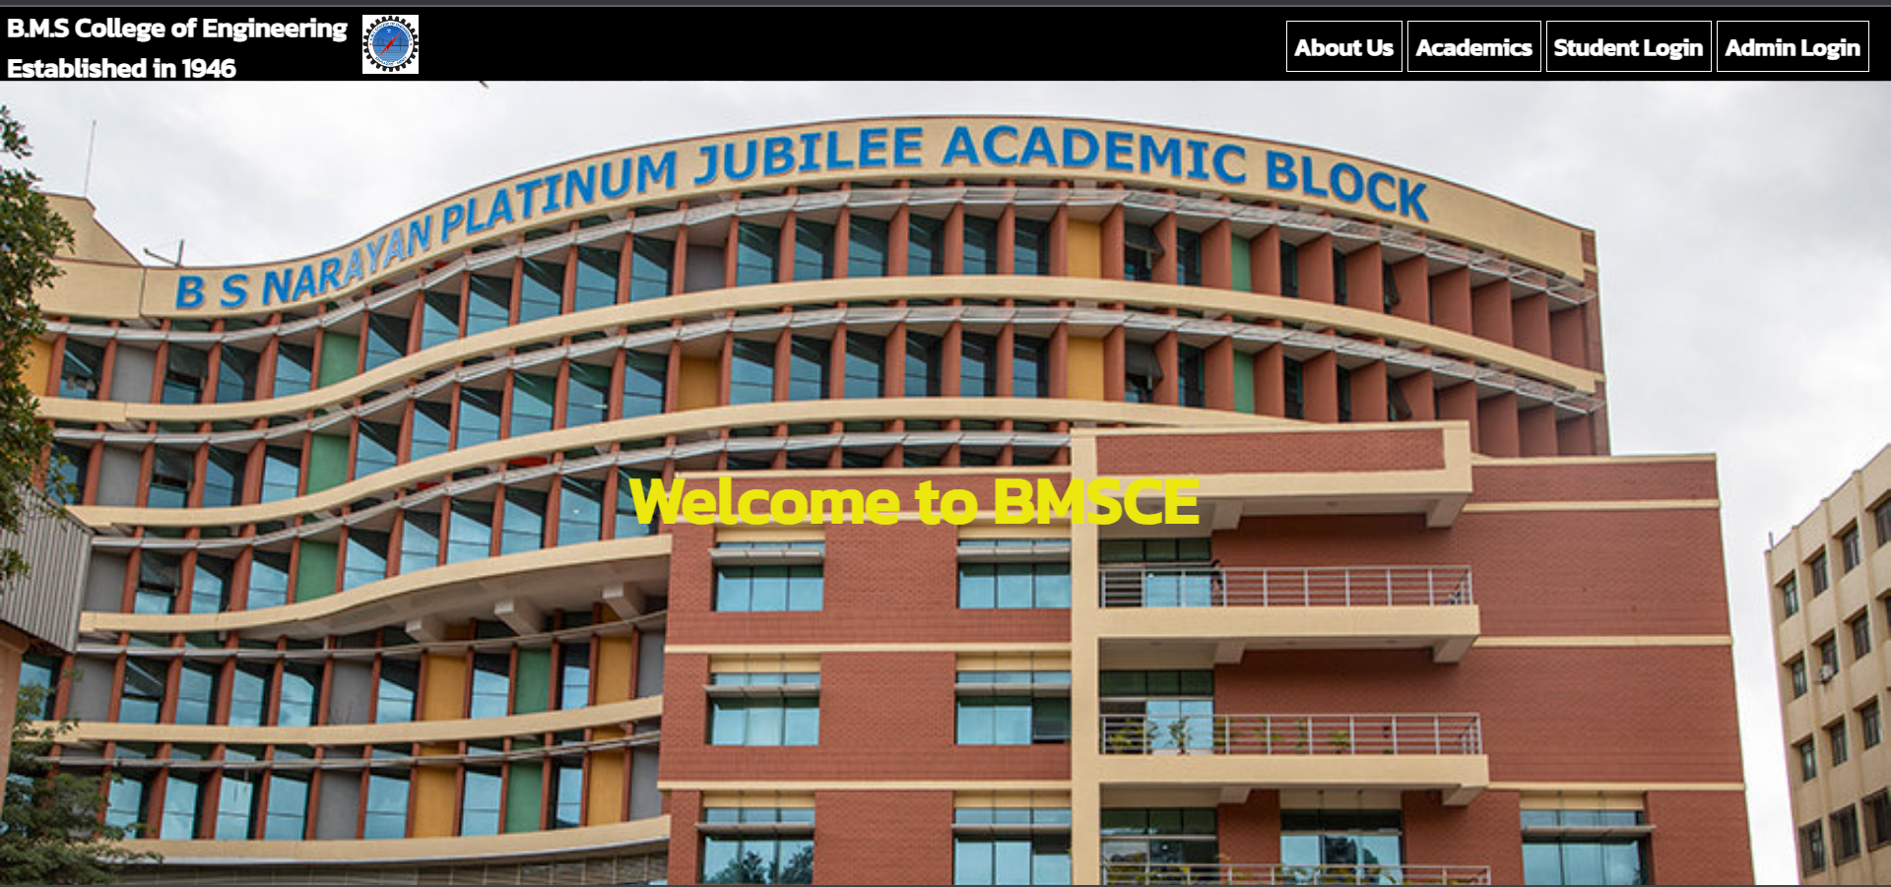

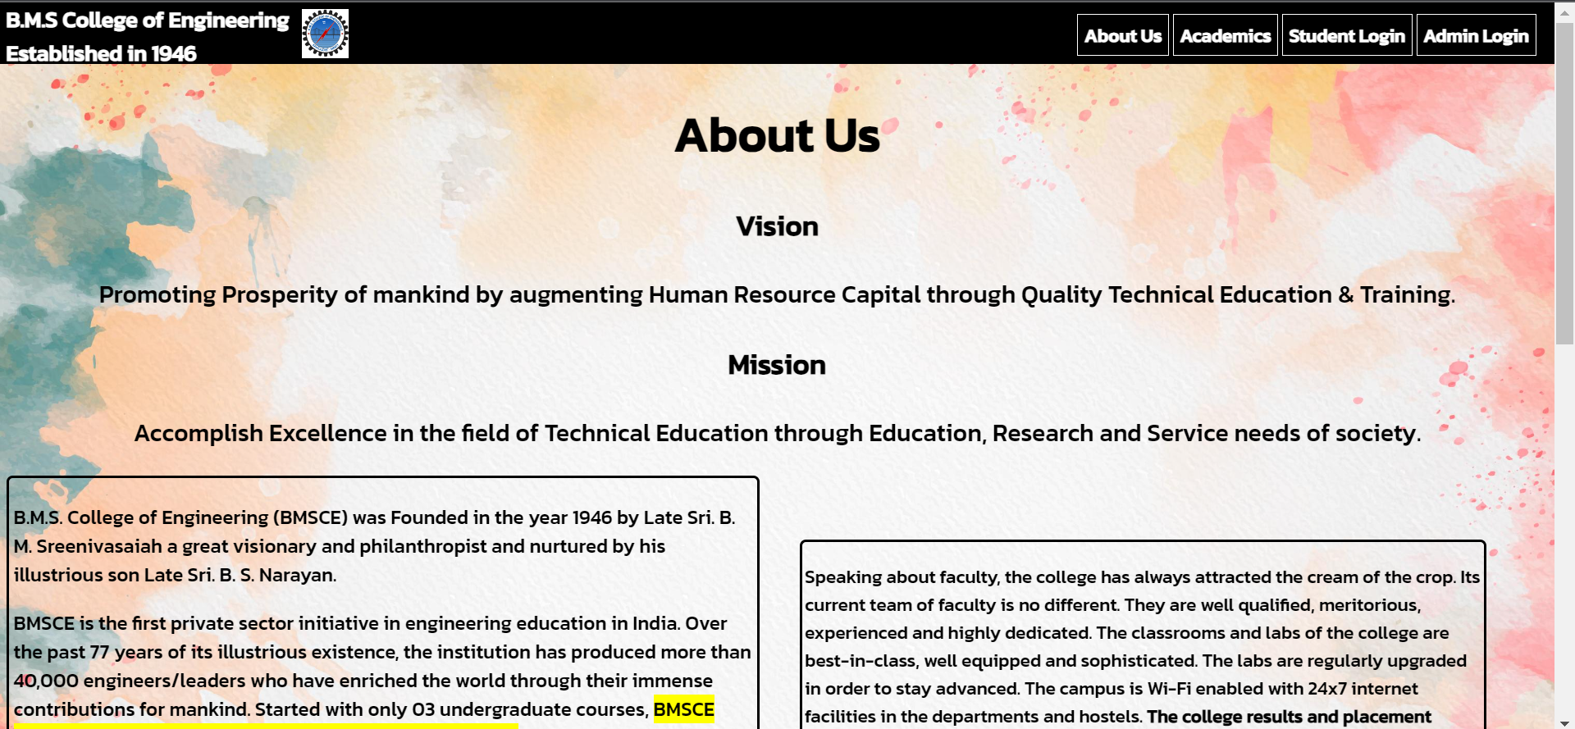

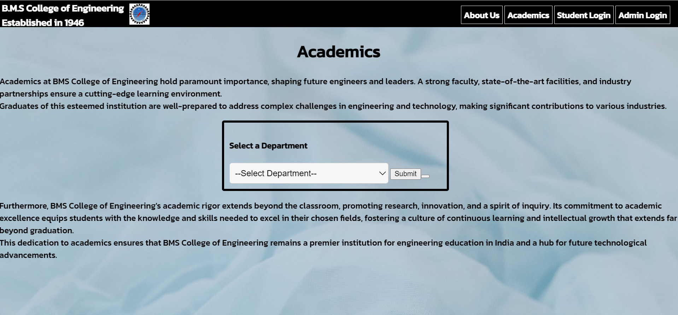

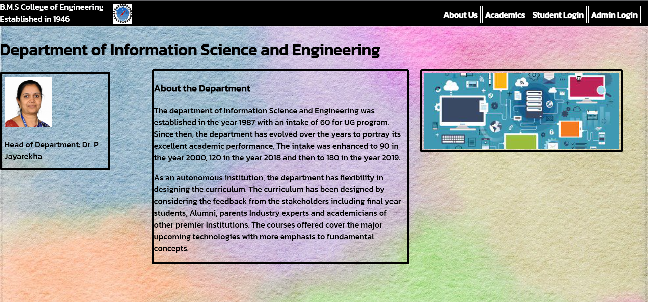

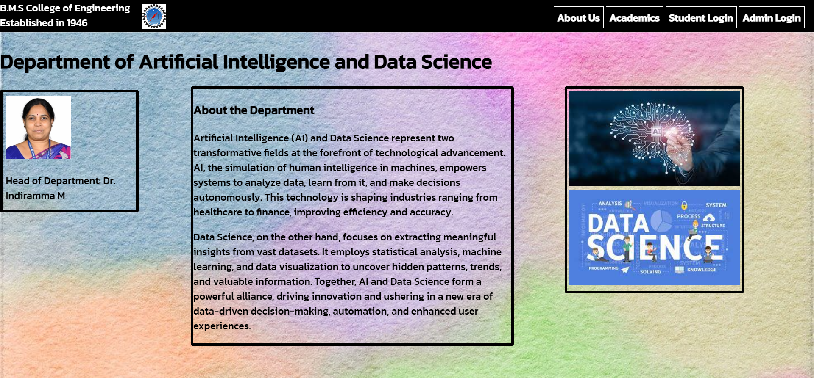

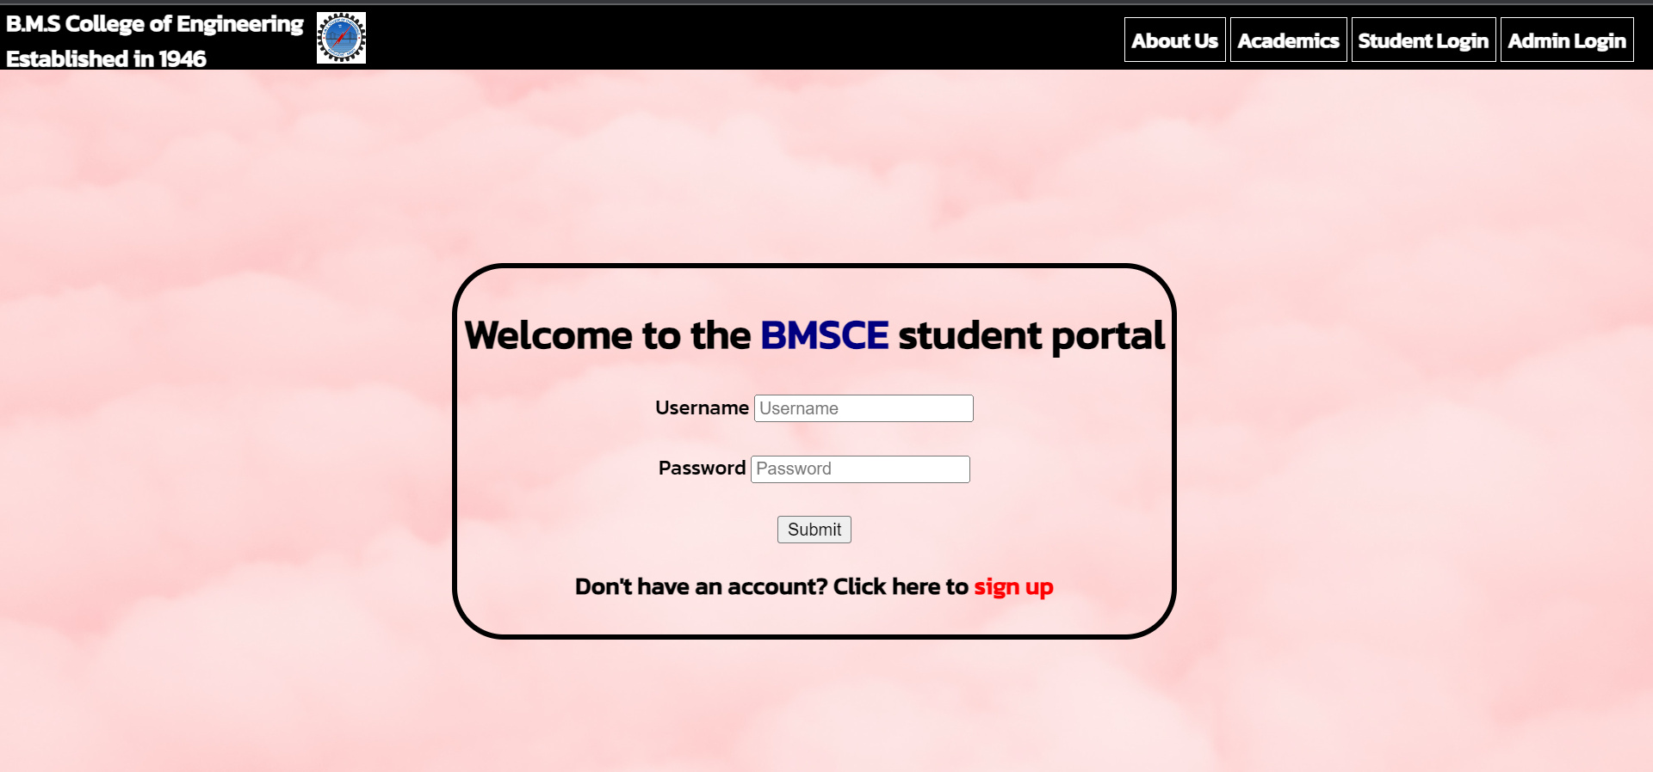

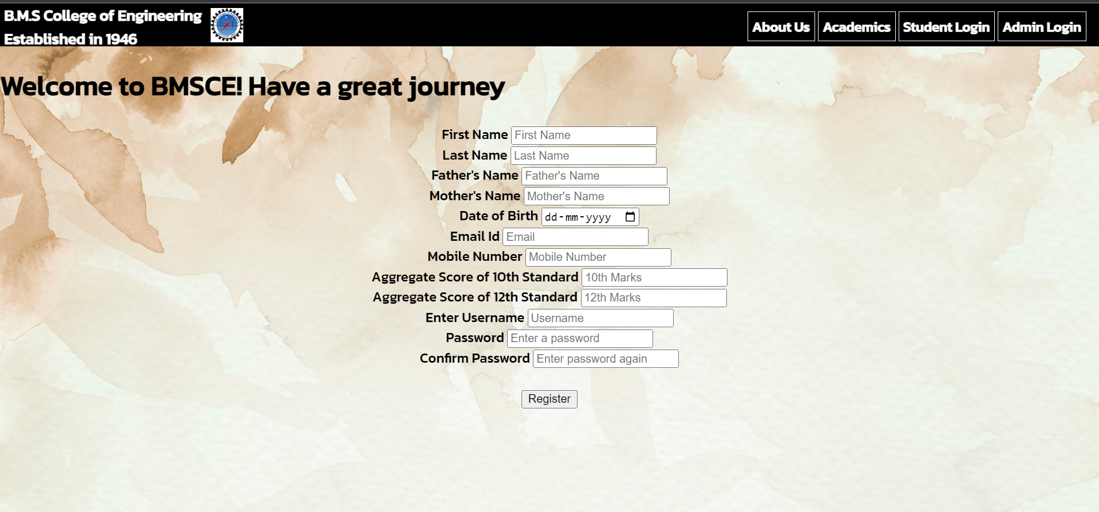

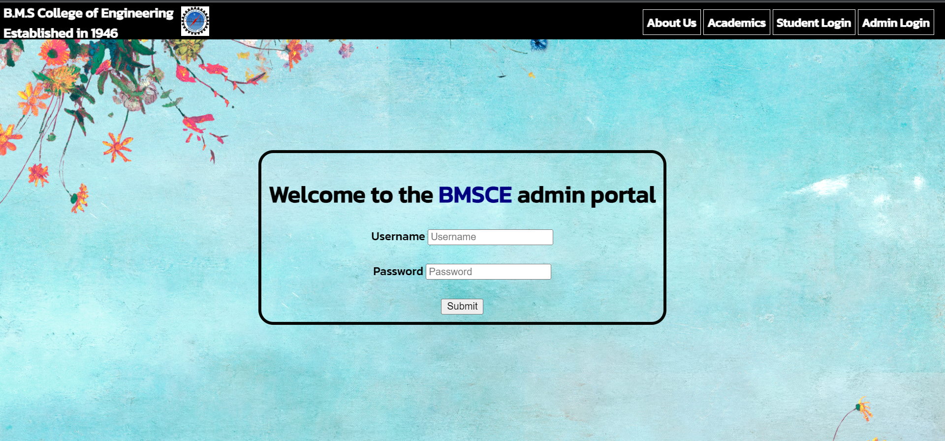

**CONCLUSION**

In summary, our comprehensive web application seamlessly integrates HTML, CSS, and JavaScript to facilitate a robust educational experience. It adeptly handles student registration, login, and profile updates, ensuring secure data management. The use of regular expressions enhances password security, and the dynamic interface simplifies user interactions.

Admins benefit from a secure login system, while students can easily update their details. Additionally, our application offers streamlined department access, enabling users to explore academic offerings effortlessly. The intuitive design ensures smooth navigation and a visually pleasing experience.

This project showcases the potential of web technologies to create user-friendly and functional educational platforms. It promotes effective communication and information access, fostering a positive and productive learning environment.